### **Database**

### **Main Table: Defect**

|  |  |  |
| --- | --- | --- |
| **Column** | **Data Type** | **Constraints** |
| Defect_ID | VARCHAR(10) | PRIMARY KEY |
| Title | VARCHAR(255) | NOT NULL |
| Description | TEXT |  |
| Module_ID | INT | FOREIGN KEY → Module(Module_ID) |
| Severity | VARCHAR(20) |  |
| Priority | VARCHAR(10) |  |
| Created_Date | DATETIME |  |
| Status | VARCHAR(50) |  |
| Assigned_To | INT | FOREIGN KEY → User(User_ID) |
| Environment | VARCHAR(50) |  |
| CreatedBy | INT | FOREIGN KEY → User(User_ID) |
| CreatedOn | DATETIME |  |
| LastModifiedBy | INT | FOREIGN KEY → User(User_ID) |
| LastModifiedOn | DATETIME |  |

### **Attachments Table**

|  |  |  |
| --- | --- | --- |
| **Column** | **Data Type** | **Constraints** |
| Attachment_ID | INT | PRIMARY KEY |
| Defect_ID | VARCHAR(10) | FOREIGN KEY → Defect(Defect_ID) |
| FilePath | VARCHAR(500) | NOT NULL |
| FileType | VARCHAR(50) |  |
| CreatedBy | INT | FOREIGN KEY → User(User_ID) |
| CreatedOn | DATETIME |  |
| LastModifiedBy | INT | FOREIGN KEY → User(User_ID) |
| LastModifiedOn | DATETIME |  |

### **History Table**

|  |  |  |
| --- | --- | --- |
| **Column** | **Data Type** | **Constraints** |
| History_ID | INT | PRIMARY KEY |
| Defect_ID | VARCHAR(10) | FOREIGN KEY → Defect(Defect_ID) |
| ChangeDescription | TEXT |  |
| ChangedBy | INT | FOREIGN KEY → User(User_ID) |
| ChangedOn | DATETIME |  |

### **Audit Table**

|  |  |  |
| --- | --- | --- |
| **Column** | **Data Type** | **Constraints** |
| Audit_ID | INT | PRIMARY KEY |
| TableName | VARCHAR(100) |  |
| Record_ID | VARCHAR(50) |  |
| Action | VARCHAR(50) | (INSERT/UPDATE/DELETE) |
| ActionBy | INT | FOREIGN KEY → User(User_ID) |
| ActionOn | DATETIME |  |

# ER Diagram

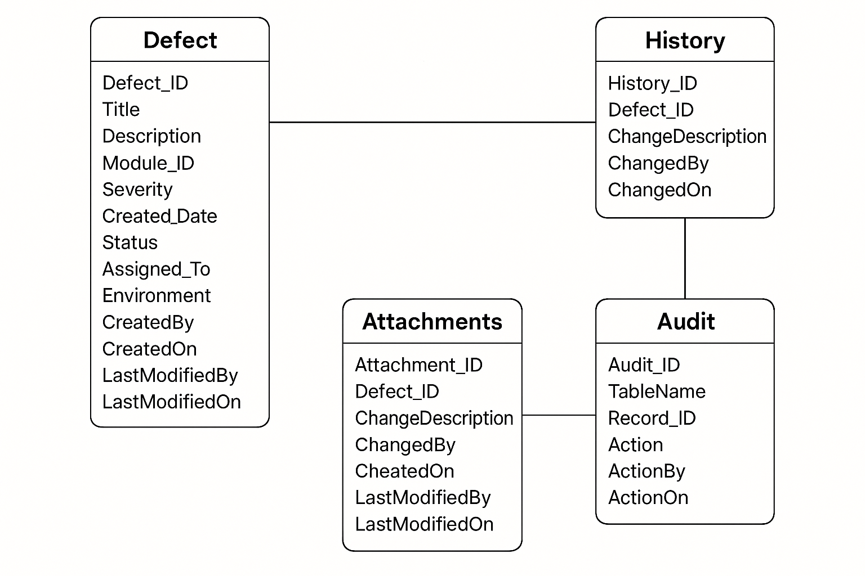

# System Diagram

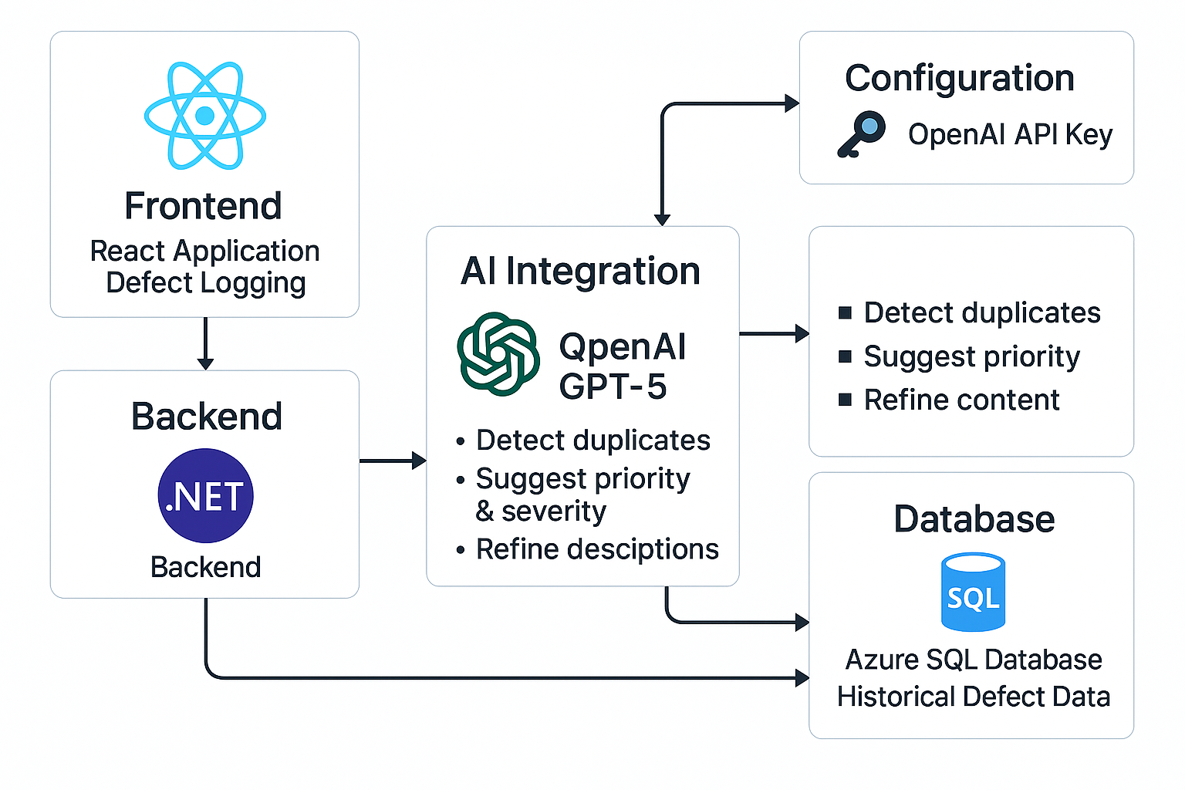

# Future Perspective

